Chapter 9 Exception Handling

1. Exception: some type of error
2. throwing an exception: mechanism that signals when something unusual happens
3. handling the exception: code that deals with the exceptional case
4. event-driven programming
   1. objects are defined so that they send events(objects) to other objects that handle the events
   2. firing an event: sending an event
5. syntax example:

**try {**

/* 重點：

1. 如果這個block有error，會中斷，並立即執行以下對應的catch block

2. 如果在這裡有error，需要用if-else statement檢查是哪一種error，

再寫throw Exception，使以下catch block接收

3. 如果在這裡執行的method有error，而且該method可回傳throw

Exception，就不需要寫if-else statement來throw Exception了

，會對應到下面Exception類別自動catch

*/

**} catch (MyExceptionType myExcept) {**

//MyExceptionType為開法者自物件類別

//myExcept為reference指向MyExceptionType物件

**} catch (Exception otherExcept) {**

//Exception為Java原始物件類別

**} finally {**

/* 重點：

1. 無論有無exception，前面的block執行完，最後這裡永遠都會執行

2. finally block在try-catch結構中可省略

*/

**}**

1. 使用try-catch重點：
   1. 不會明確知道try block哪一行出問題，因為到底哪一行出問題不重要
   2. 若在try block呼叫的method可回傳throw Exception，就可以省去在try block內寫一大堆if-else的檢查機制
   3. catch block只有遇到錯誤才會直行。執行完後會立即執行finally block
   4. finally block可省略，並非必要的。finally block無論有無錯誤都會執行
2. ArrayIndexOutOfBoundsException example

public class HelloException {

public static void main(String[] args) {

int i=0;

String greetings[] = {

"Hello world!",

"hello",

"world",

};

while(i<4){

try{

//不需要寫if-else，超出範圍直接catch

System.out.println(greetings[i]);

i++;

} catch (ArrayIndexOutOfBoundsException e){

System.out.println("catch");

break;

} finally{

//無論有無錯誤都會執行

System.out.println("Always printed");

}

}

}

}

1. self-defined example

//derived from Exception

public class DividedByZero extends Exception {

public DividedByZero(){}

public DividedByZero(String message){

super(message);

}

}

public class Test {

//func會可回傳throw DividedByZero Exception，所以try-catch可

//以不用寫if-else

public static int func(int x, int y) throws DividedByZero{

if(y == 0){

throw new DividedByZero("divided by 0");

}

return x/y;

}

public static void main(String[] args) {

int a = 0;

int b = 0;

//真正要用try catch應該在這裡，而非在func內部

//func會throw exception，如果在這裡不寫try-catch會有

//warning

try{

func(a,b);

} catch (DividedByZero e){

//Exception class有data member存取error message

System.out.println(e.getMessage());

}

}

}

1. Exception Controlled Loops，例如：網路連線會不斷地試圖連線

boolean done = false;

while (! done) {

try {

CodeThatMayThrowAnException

done = true;//execute only when there is no exception

} catch (SomeExceptionClass e){

SomeMoreCode

}

}

1. Exception Classes from Standard Packages(java.lang package)
   1. for example: Exception, IOException, NoSuchMethodException, FileNotFoundException
      1. Exception has getMessage method
         1. there is a String arguement in the Exception constructor
   2. more info: <http://docs.oracle.com/javase/7/docs/api/java/lang/Exception.html>
2. Other Exception Classes should be imported from java.io.IOException
3. multiple catch blocks
   1. when catching multiple exceptions, catch the more specific exception first
   2. when an exception is thrown in a try block, the catch blocks are examined in order, and the first one that matches the type is executed
   3. for example:

public static int func(int x, int y){

boolean fail = true;

try{

if (y == 0)

throw new MyException("divided by 0");

if (fail == true)

throw new MyException2("fail boolean");

} catch (MyException e){

System.out.println(e.getMessage());

System.exit(1);

} catch (MyException2 e){

System.out.println(e.getMessage());

} catch (Exception e){//越general的exception寫越後面，

//以免會接收了所有Exception的繼承者

System.out.println(e.getMessage());

}

return x/y;

}

1. throwing an exception in a method
   1. 請見重點9
   2. if a method can throw more than one type of exception, separate the exception types by commas, for example:

public void aMethod() throws AnException, AnotherException

* 1. 以上AnException和AnotherException具備covariant特性，故可以回傳其derived class

1. Catch or Declare Rule
   1. only two techniques to catch
      1. try block throws an exception, and catch block catches the possible exception within the same method
      2. possible exception is declared at the start of the method definition, and returns a “throw exception” if error occurs (throwing an exception in a method)
   2. both techniques can be mixed
2. checked exception: errors that occur in a correct program
   1. Exception, Throwable, and all descendants of Exception deals with such errors
   2. must use Catch or Declare Rule
3. unchecked exceptions: fatal errors
   1. fatal situations: Error and its descendant classes deals with such errors
   2. not subject to the Catch or Declare Rule
   3. case example: memory space not enough

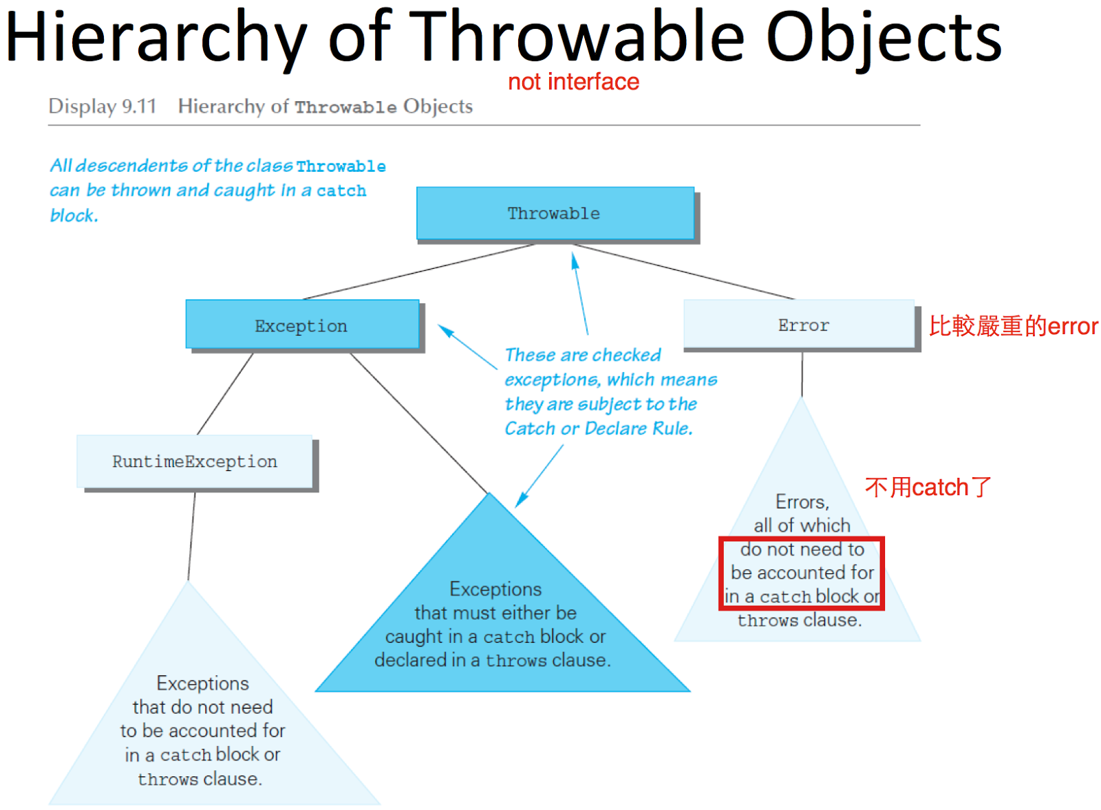

1. Nested try-catch blocks
   1. try-catch block in catch block
      1. must use different names for catch block parameters in inner and outer blocks
   2. try-catch block in try block
      1. if an exception is not caught in the inner block, then it will be thrown to the outer block
2. Rethrowing an Exception
   1. catch block has code that throws an exception
   2. sometimes catch an exception, and check getMessage, and then thrown to somewhere else
3. main method可以加上throw
   1. for example:

public static void main(String[] args) **throws Exception**

* 1. compile的時候不會出錯，但是runtime時候會出錯